Import and Export of Goods and Services

Your Name

Import and Export of goods and services decrease the currency risk and better profit for the country. If the import and export increases then the country's economy condition is also going better as the year passed. If the import and export are low then there are many crises born in the country like all the goods, petrol, and daily supply of food is decreasing badly. So, the more the import and export of goods and services increase more the country's economy condition.

This table shows the Imports of goods and services (BoP, current US$) from 1980-2020 in United Kingdom, France, South Africa, and Germany.

|  |  |  |  |  |
| --- | --- | --- | --- | --- |
| **country** | **United Kingdom** | **South Africa** | **France** | **Germany** |
| **1980** | 134200000000 | 22143220000 | 154336100000 | 222272200000 |
| **1985** | 127773700000 | 12996670000 | 127656200000 | 184376500000 |
| **1990** | 264089500000 | 21017050000 | 283183500000 | 411514400000 |
| **1995** | 327000400000 | 33374910000 | 333745800000 | 558503100000 |
| **2000** | 446919600000 | 33074960000 | 377318200000 | 595331400000 |
| **2005** | 696935200000 | 68723060000 | 593171100000 | 933452200000 |
| **2010** | 749615000000 | 102974100000 | 752868300000 | 1263115000000 |
| **2015** | 849567800000 | 100802800000 | 787378200000 | 1320209000000 |
| **2020** | 776091600000 | 79013330000 | 808171700000 | 1454493000000 |

**Table: Import of Goods and Services 1980-2020**

The line graph shows that all the countries' import increase year by year passes except one country, South Africa. South Africa's import of goods and services is slightly increasing.

The bar graph shows that Germany's country imports increased highest and South Africa's imports increased to the lowest number.

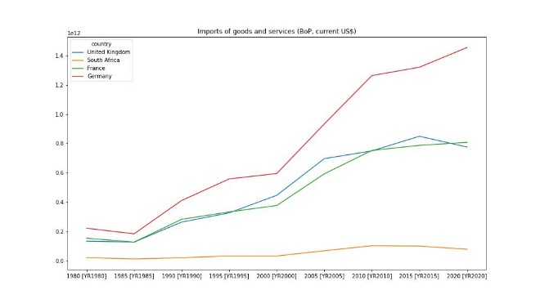

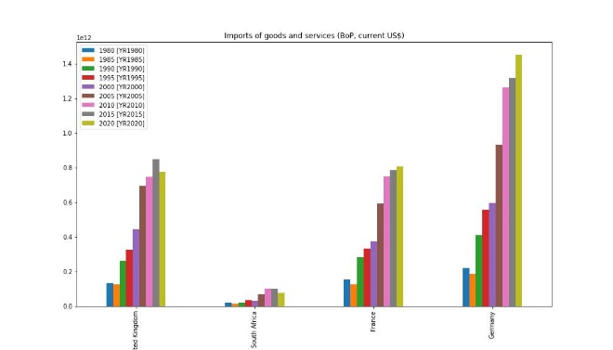

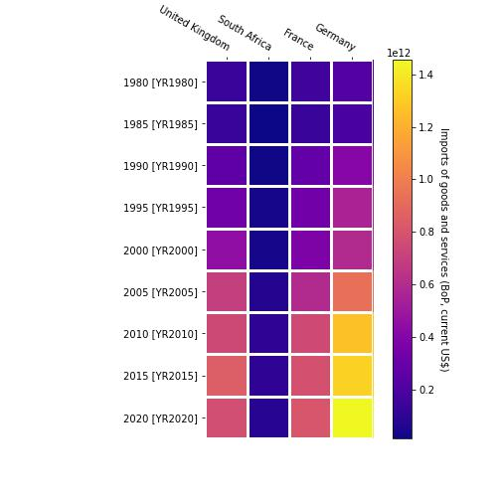

In the heatmap graph, the yellow box shows the more import, and the bluer box shows the import is too low.

This table shows the Exports of goods and services (BoP, current US$) from 1980-2020 in United Kingdom, France, South Africa, and Germany.

|  |  |  |  |  |
| --- | --- | --- | --- | --- |
| **country** | **United Kingdom** | **South Africa** | **France** | **Germany** |
| **1980** | 146072000000 | 28501650000 | 151617700000 | 217390700000 |
| **1985** | 132168000000 | 18030790000 | 132509000000 | 207284500000 |
| **1990** | 239226100000 | 27160240000 | 285334900000 | 457349900000 |
| **1995** | 322113900000 | 34402140000 | 362717000000 | 569039000000 |
| **2000** | 419615600000 | 36995350000 | 390238700000 | 599192200000 |
| **2005** | 637110900000 | 68089720000 | 592887800000 | 1082220000000 |
| **2010** | 702682400000 | 107953700000 | 709353200000 | 1443338000000 |
| **2015** | 803703000000 | 96346520000 | 777544700000 | 1575247000000 |
| **2020** | 782997900000 | 94116510000 | 759609700000 | 1675612000000 |

**Table: Export of goods and services 1980-2020**

The line graph shows that the export of goods and services increasing year by year. Germany's Export of goods and health is the highest and south Africa is the lowest country in the export of goods and services.

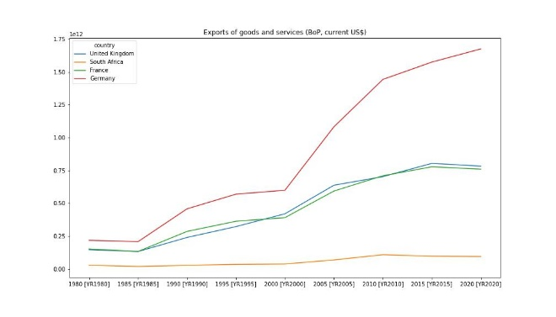

Export of goods and services Line graph

The bar graph shows that the export of goods and services highest import increase by year is Germany. The lowest export of goods and services is South Africa. So the import and export chart analysis say that the economic condition of Germany country is better than the other.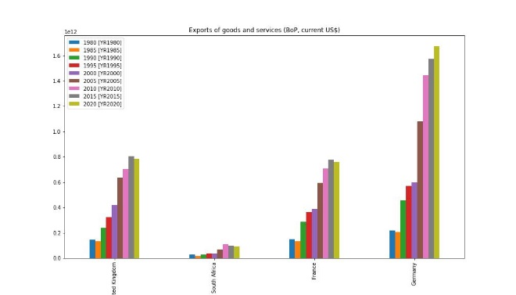

Export of goods and services Bar Graph

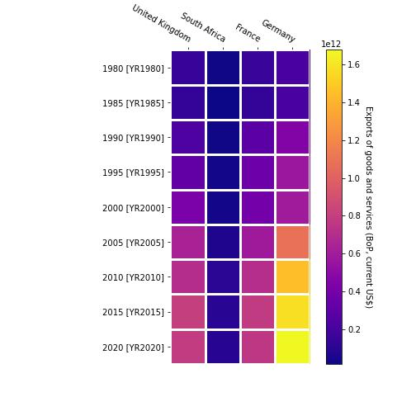

Export of goods and services Heatmap Graph

In the heatmap graph, the yellow box shows the more export, and the bluer box shows the export is too low.